From: https://www.davidstockmanscontracorner.com/the-malefic-comfort-ladies-of-wall-street/?mc_cid=27fd1ca443&mc_eid=23bf5d4e64
The Malefic Comfort Ladies Of Wall Street
What the hell?
Have these fools in the Eccles Building completely lost their minds? Have they become so dense and craven that there is no limit to the amount of fiat credit and liquidity they will pour into Wall Street to satisfy the crybabies, bullies and infinitely greedy, entitled bastards who operate there?
With the $1.175 trillion of the new repo facilities announced yesterday on top of the $4.31 trillion of footings at the March 12 close, the Fed’s balance sheet could soon hit $5.4 trillion. So doing, it would have blown past in a matter of hours the madness that Bernanke launched in the fall of 2008.
And for want of doubt, we are talking trillions with a “T” here. It took the Fed’s balance sheet 94 years from its 1914 opening to reach the $1 trillion mark when Bernanke panicked in September 2008.
And, now, in a matter of less than 24 hours they have created another trillion of balance sheet for no good reason whatsoever.
Well, there is a reason and its rather unspeakable. Call them the Malefic Comfort Ladies of Wall Street and understand thereby what they really o.
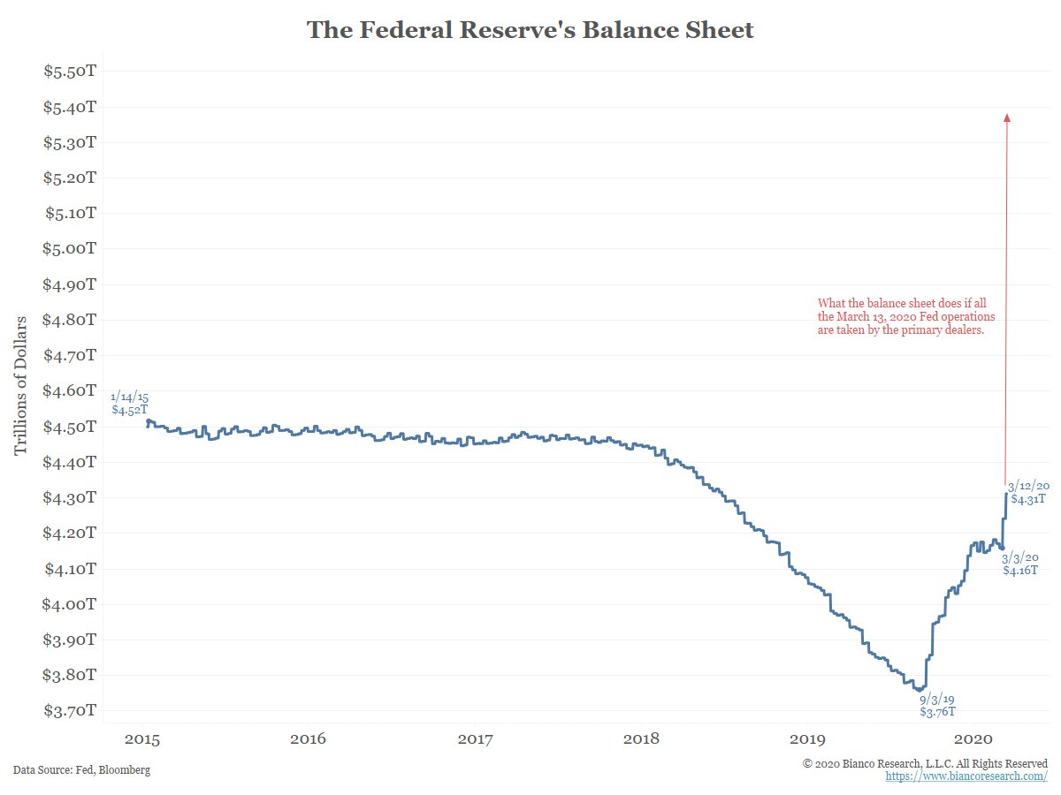
Of course, to hear Wall Street tell it there is a purportedly a stupendous problem in the financial system plumbing, whatever that is. The gumming among the talking heads, in fact, reached a fever pitch when bond prices tumbled and yields soared Thursday afternoon after a lukewarm Treasury auction.
These spiking bond yields during a massive risk off-day when the stock averages plummeted by 10%—the worst since the legendary Black Monday meltdown of October 1987—were allegedly evidence that liquidity had evaporated in the bond pits. Yields were supposed to plunge, not soar, owing to flight to safety buying—so the cry went out for the Fed fireman to come bounding into the casino with liquidity hoses pumping at full pressure.
In that regard, we heard one of the CNBC talking heads today whining that bond trades weren’t getting done, and that if you needed to “sell in size”, you couldn’t get it done.
Baloney! That’s complete, unadulterated, risible crap—just more of the same self-serving con job that continuously emanates from the Wall Street gambling pits and which the Fed never stops accommodating.
So we will say it again: There was and is absolutely no shortage of “liquidity” in the financial system—just a shortage of market clearing trades at the ridiculously low 1.05% rate that the Fed insists on foisting upon the money market (and by all accounts from Wall Street “strategists”, it’s heading for 0.05% at the upcoming March meeting).
If these monetary arsons [arsonists] just got their Big Fat Thumbs off money market rates, however, so-called “liquidity” would reappear in a nanosecond, albeit at far higher interest rates than those dictated by the Fed.
Yet that’s exactly what the entire financial market and US economy needs: Namely, higher market clearing rates which would shutdown the leveraged gamblers, remind politicians that fiscal borrowing is not a free lunch and force C-suites to think twice about trashing their own balance sheets with debt in order to fund Wall Street pleasing stock buybacks and M&A deals.
In short, yesterday’s so-called liquidity squeeze was just the inverse side of the coin stemming from the Fed’s heavy-handed attempts to destroy the law of supply and demand in the bond pits and the money dealing rooms.
After all, let rates clear the market and excess demand for funding will be destroyed and new supply of funds will come out of hiding if it can earn a requisite return for the risk.
For example, how about rewarding real money investors with a higher yield on Treasury bonds owned outright rather than depending upon leveraged high-rollers to buy the Treasury bonds at infinitesimal yields and then attempt to strip out profits through interest rate arbitrage?
The laws of supply and demand, in fact, are perfectly serviceable for rents, Coca-Cola, jet fuel, hand sanitizers and millions of more products—so why does the Fed endlessly attempt to override them in the financial sector?
Do these cats really think the supposed strongest economy in the world can’t stand 3%, 4% or even 6% money market rates, if that’s what the free market would generate?
If they do, they should be fired for incompetence because the historical record leaves no room for doubt. For instance, during the technology boom between 1994 and 2000, the short-term money market rate as proxied by the 90-day T-bill (purple line) ranged between 4% and 6%; and that wasn’t distorted by high inflation, either. The spread over core CPI (brown line) averaged between 200 and 300 basis points during the entire period.
More importantly, real GDP growth averaged 3.92% per annum and real median family income grew by 2.2% per annum during the same period. That’s the best macro performance of the last 50 years!
So the excuse that the Fed is flooding Wall Street with hideous amounts of liquidity and driving money market rates to the zero bound in order to prevent an interest rate crunch from felling the US economy just doesn’t wash.
They are doing this because the fools in Washington have given them open-ended statutory authority to print as much fiat credit as they want and to rig, peg and fiddle with any interest rate or security price that strikes their fancy.
To be sure, the Fed heads claim that all of this massive intrusion in the financial system and repression of actual market prices for money and financial assets is being done for the good of the main street economy, not to pleasure the Wall Street speculators.
But exactly what hay wagon do they think we fell off from?
Do they really think everyone is so stupid as to be unable to tell that they are completely in the tank for Wall Street and that all the rest of their macro-economic jibber-jabber is just a cover story and rationalization for their own abject cowardice?
The truth is, they have created the mother of all financial bubbles over the last 10-years, and are now doing nothing more than begging Wall Street to keep it aloft, lest it come crashing down on the main street economy and thereby eviscerate their credibility and continued possession of essentially dictatorial financial powers.
For crying out loud, just minutes ago we heard some self-impressed talking head from Morgan Stanley assure with great confidence that the Fed will cut interest rates by 100 basis points (!) at the next meeting (and launch a massive new QE program, too).
Because why?
So that some customer-less restaurant owner can pawn his kitchen appliances and hardware for 0.05% repo funding?
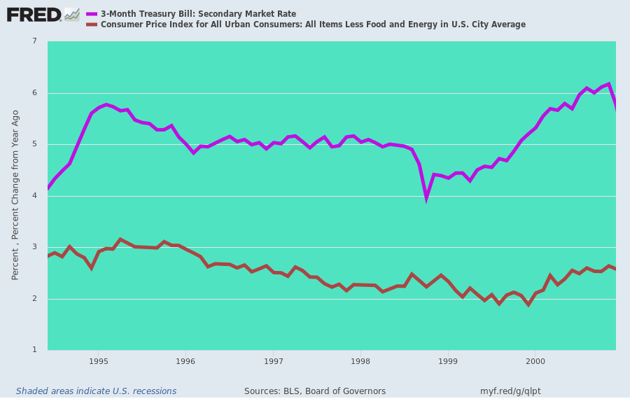
You need only listen to the bubble-vision chatter today out of one ear, and you quickly get that all of this insane money pumping is about bailing Wall Street speculators out of misbegotten trades that are now blowing up in their faces. Wall Street has essentially hijacked it very own legal printing press.
For instance, one of the complaints emanating from the crybabies today is that the bid/ask spread blew way out in the Treasury and corporate bond pits yesterday. That is, sellers were “asking” far more than dealers and the corporals’ guard of buyers/traders/speculators were willing to bid.
So what?
These same dudes who couldn’t “sell in size” yesterday have been minting money on the Fed’s credit card for months and years via buying 3, 5, 7, 10 and even 30-year Treasury paper on 95% repo at virtually no carry cost, and laughing all the way to the bank as they pocketed the arb.
Then comes a moment of panic and the only “bid” they can get for their UST’s would result in a deep capital loss and the wiping-out of their accumulated arbitrage profits.
But we repeat ourselves. So what!
This is rank gambling and has nothing whatsoever to do with the legitimate conduct of central banking; and it most certainly has nothing to do with the health of the main street economy or the promotion of sustainable prosperity for the everyday folk whose savings are being savaged and paychecks being clipped by the low-interest, pro-inflation policies of the central bank.
Needless to say, none of this Wall Street whoring by the Fed is a dark secret. Yesterday’s extraordinary and massive flush in the stock and bond pits alike was in part driven by one of the most malignant concoctions that have been brewed on Wall Street.
We are referring to the so-called “risk parity” funds and trades, which in essence employ massive amounts of ultra-cheap short-term leverage to short both stock and bond volatility. At the moment there are upwards of a trillion dollars in explicit risk party funds like the monster pool run by Ray Dalio, and trillions more in trades that ape and simulate the same.
Needless to say, these are the products of the Fed-fostered devil’s workshop of finance. On an honest free market there would be zero profits in these concoctions, and accordingly something close to zero capital and investible assets would flow to them.
Technically, the way these risk parity funds work is to constantly drain the volatility from the aggregate bond and stock holdings of their portfolio. Thus, under normal “risk-off” patterns, stock volatility rises and bond vol falls—so they sell the former and buy the latter to rebalance.
But yesterday both markets were falling at the same time, which meant that vol was soaring on both sides of the risk parity portfolios. Accordingly, they were dumping both types of securities hand over fist into markets which were gaping down—-or, at least, 2300 Dow points to the south would suggest as much.
Yet that was only the half of the matter. On the arithmetic of it, the more leveraged the risk parity fund, the more it had to sell in order to purge the surging vol, which on the stock side saw the VIX erupt above 75.
As the chart below shows, on the eve of the Covid-19/Oil-30 meltdown in the financial markets, the risk parity funds were more leveraged than ever before, with their gearing touching more than 550% (they had 5.5X more assets at work than investor capital).
Here is the picture which drops the dime on yesterday’s so called “liquidity” crisis. To wit, the risk parity funds were dumping massive amounts of securities “in size”, as they liquidated more than two turns of leverage in a single day!
Yet these thieves, who were literally minting money up there at 550% leverage, now have the gall to demand that the central bank come in to pump a floodtide of liquidity into unhinged markets from which they have been strip-mining ill-gotten rents for years and years.
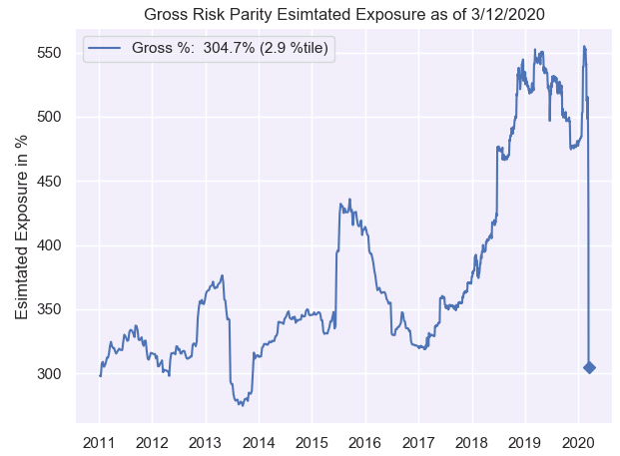
Here’s the thing. The financial markets are riddled with these kinds of malignant speculations. They would never, ever happen without central bank suppression of money market costs and the falsification of bond prices, yield curves and capitalization rates for stocks, real estate and their derivatives—most especially options on the same.
Unfortunately, the labor economists, Keynesian ideologues and liberal do-gooders who populate the Fed are clueless about the malignancies they have been gestating in the dark corners of the financial system.
So when the markets finally snap from their own egregious excesses, the Fed heads panic and listen to the self-serving clap-trap emanating from Wall Street.
Among the dispensers thereof, none is more odious than the unctuous proprietor of Bridgewater, Ray Dalio. At strategically timed intervals he steps out of the shadows to dispense on bubble-vision alleged morsels of wisdom, which amount to nothing more than talking his own book.
As Zero Hedge noted, less than two months back when he was minting billions shorting vol, he stepped forward to inform the unwashed bubblevision audience that “cash is trash”.
That is to say, buy stocks and bonds and make me even richer shorting the crashing vol.
Alas, yesterday Ray Dalio got his just deserts as in virtually a split second of market time, Cash became King and the risk parity brigade was sent to the slaughterhouse.
And we are not sure that this time, even the fireman from the Eccles Building came make them whole.
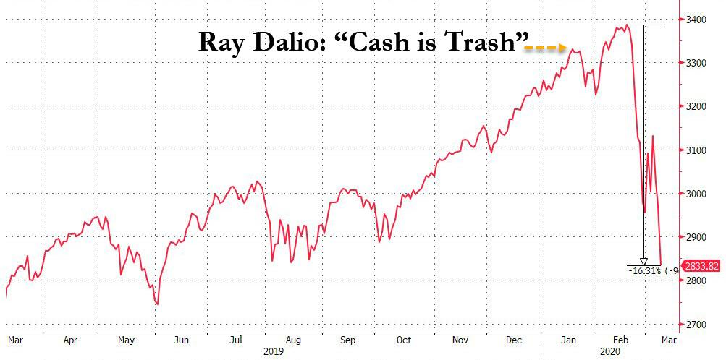
Given the above errant call by the Risk Parity King himself, you really can’t be too hard on the Trump Organization for their own recent misfired market calls. It seems that Eric and the Donald, like Ray Dalio, are now scrambling to figure out how the monetary and fiscal tools of the Federal government can be abused to keep the myth of MAGA alive.
Let us say here that bald-faced larceny is in the pipeline down in Washington, as we well [will] amplify further next week.

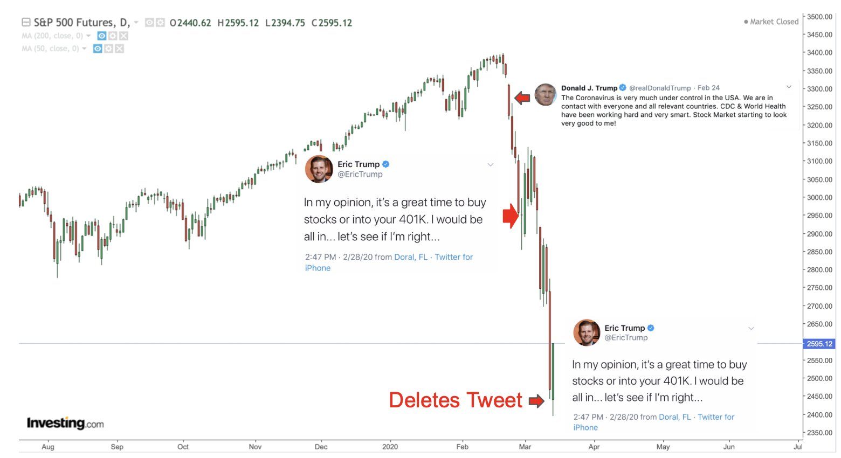
But in the meanwhile, we leave it to the great David Rosenburg to cut to the quick of this weeks’ insanity, and remind that Covid-19 is indeed the neutron bomb of economics.
Even if a million Americans become infected after “social distancing”, 98% will remain standing: It is the economy all around them which is going down for the count and there is virtually nothing our money printers and Big Spenders can do in time to make a difference:
-….. I mean, what can they do here? Buy airline tickets? Buy cruise ship tickets? Buy empty seats at the hockey, basketball and baseball games(when they start back up again)? Maybe that is what they should do. They could work with the Treasury (MMT) and dump money into people’s accounts but if they are not going to go to the movies, out for dinner, to a conference that gets cancelled, or fly somewhere, then who cares?
So…at 11 p.m., Dow futures were down more than 600 points and now are up nearly 1,100points. As if we haven’t seen this sort of manic swing before in recent weeks. The bull market in uncertainty, volatility, illiquidity and schizophrenia remains fully intact. What remains unchanged is how the pandemic and oil price carnage have derailed the global market for corporate credit, suffering its worst week since the financial crisis and CDS spreads (that measure default risk)have jumped at a pace last seen nine years ago. What comes out of all this, that makes the global recession worse, is a credit crunch. According to Bloomberg, hundreds of European companies in the high-yield market face a debt refinancing calendar that tops $100 billion in the next few months
But the reality is that no two recessions are ever the same. The 1990-91 and 2001 recessions had nothing to do with the banks. This is about a credit contraction in the nonbank financial sector, where the debt bubble resides this time.
When you look at all the sectors now facing a crunch, and we are talking about airlines, energy, retail, restaurants, leisure/hospitality, and entertainment, this is so big that the direct hit is on 40 million workers or nearly one-third of the private sector staff loads. It’s tough to see how this turns out to be a mild recession with consumer spending about to come under the knife and any recovery will be muted even with policy stimulus.

